Zeolite for oxygen enrichment from air
Oxygen is one of the important elements to live the humans. All human breath/takes oxygen from atmospheric air which content: 78.08% nitrogen, 20.95% oxygen, 0.93% argon, 0.04% carbon dioxide, and small amounts of other gases. During the pandemic situation, our country is faced huge shortage of medical grade oxygen for the treatment of COVID 19 patients. As per reports, it is predicted that this type of situation/pandemic can occur in the near future. Therefore, we should be ready to get medical grade oxygen (+96% purity), which is the primary need of each human.
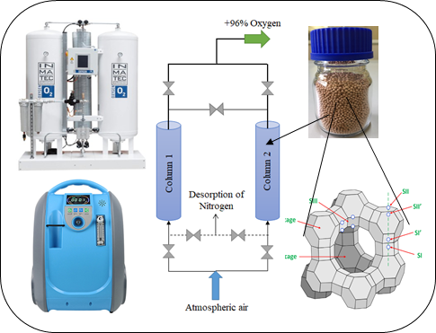
Pressure Swing Adsorption (PSA/VPSA) is a simple, cheap and promising technique to separate oxygen from the atmosphere air. PSA unit can build in the hospital premises to excess pure oxygen. However, it requires the porous adsorbent which is heart of this process, and help to adsorb nitrogen and release oxygen. Lithium-exchanged Low Silica X (Li-LSX) Zeolite has large nitrogen adsorption capacity due to its physical properties. CSIR-NCL, Pune is working on oxygen enrichment and develop the Li-LSX zeolite, as well as tested in a laboratory. As projected, Li-LSX zeolite adsorbs large amounts of nitrogen: 18 to 22 mL/g, which is close to the commercial material. This indigenous Li-LSX zeolite helps to produce high purity oxygen (+96%) via PSA/VPSA unit which will further useful for treatment of patients in the hospitals. Along with Li-LSX, Ca-LSX zeolite process is also designed for high purity of oxygen. Besides medical use, high purity oxygen has wide industrial applications including gas cutting and welding, Steel, Pharmaceutical, Petroleum, Glass, Ceramics, oxidation reactions, pulp, and paper.
For technical details, please contact:
Oxygen Team, CSIR-NCL, Pune
www.ncl-india.org
Phone: +91-20-25902258, 25902105

