Development of catalytic process for production of bisphenol-A
4,4’Bisphenol-A (BPA) is a very important feedstock for the production of epoxy resins, polycarbonate and number of other polymers. The global market for Bisphenol-A estimated at 6.2 Million Tons in the year 2020, is projected to reach a revised size of 7.1 Million Tons by 2027, growing at a CAGR of 2% over the analysis period 2020-2027. India imports BPA of about 1,35,000 TPA. CSIR has started Bulk Chemical mission mode projects in 2020 and the aim of project is to develop cost effective, eco-friendly processes for the production of Bulk Chemicals. Another important aspect of proposed project is to serve the country with its contributions to ‘Make in India’ program and towards Aatma Nirbhar Bharat.
A catalytic batch process for the preparation of Bisphenol-A using phenol and acetone in the presence of catalyst (ion resin) has been developed. The effect of various parameters has been studied and optimum reaction condition has been established. Commercial two resins show more than 95% conversion of acetone and 85-90% selectivity for BPA. Reusability and recyclability of IER has been studied in order to understand the stability of IER and found IER was robust. A batch pilot scale reaction was also performed using 5 L high pressure reactor in order to understand scalability of the process and overall material balance of the process. It was found that around 92-96 % yield and 99.5-99.8 % purity of Bisphenol-A was achieved in batch pilot scale process.
Based batch experimental data, a continuous catalytic pilot scale process has been designed and developed for the production of BPA. The BPA pilot plant trials were taken on continuous basis 24*7 for nearly 20 days. Nearly complete conversion (90-99%) of acetone was achieved at steady state operation. From the continuous pilot plant trials it was found that the catalyst used in the process was very robust and producing good yield for BPA without deactivation of catalyst since more than 18 days of reaction. A highly pure colourless BPA produced in the continuous process.

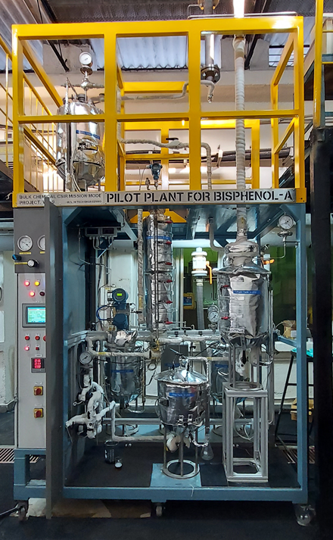
Bisphenol-A @ Process Development Laboratory, CEPD

A novel downstream processing technique has been also developed to get highest purity colorless Bisphenol-A product. The physicochemical properties of synthesized BPA were compared with commercial BPA sample and found matching. Based on this project work a patent disclosure has been filed #2022-INV-09.

